MOBILE COMPUTING

LAB NO 05

Objective: Chat Bot Generation

Submitted by:
Wasif Ali (245187)
BSCS F’24 4-B

Submitted to:

Sir Haris

Department of Computer Science
Air University - Aerospace and Aviation Campus, Kamra

Task Chat bot:
Code:
import 'package:flutter/material.dart';
import 'package:http/http.dart' as http;
import 'dart:convert';
void main() {
runApp(const MyApp());
}
class MyApp extends StatelessWidget {
const MyApp({super.key});
@override
Widget build(BuildContext context) {
return MaterialApp(
title: 'AI Chatbot',
theme: ThemeData(
colorScheme: ColorScheme.fromSeed(seedColor: Colors.deepPurple),
useMaterial3: true,
),
home: const ChatPage(),
);
}
}
class ChatPage extends StatefulWidget {
const ChatPage({super.key});
@override
State<ChatPage> createState() => _ChatPageState();
}
class _ChatPageState extends State<ChatPage> {
final TextEditingController _controller = TextEditingController();
final List<Map<String, String>> messages = [];
bool isLoading = false;
String apiKey = "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";
Future<void> sendMessage() async {
if (_controller.text.isEmpty) return;
String userMessage = _controller.text;
setState(() {
messages.add({"role": "user", "content": userMessage});
isLoading = true;
});
_controller.clear();
try {
final response = await http.post(
Uri.parse("https://openrouter.ai/api/v1/chat/completions"),
headers: {
"Authorization": "Bearer $apiKey",
"Content-Type": "application/json",
},
body: jsonEncode({
"model": "openai/gpt-3.5-turbo",
"messages": messages,
}),
);
if (response.statusCode == 200) {
final data = jsonDecode(response.body);
String reply =
data["choices"][0]["message"]["content"];
setState(() {
messages.add({"role": "assistant", "content": reply});
isLoading = false;
});
} else {
setState(() {
messages.add({
"role": "assistant",
"content": "Error ${response.statusCode}: ${response.body}"
});
isLoading = false;
});
}
} catch (e) {
setState(() {
messages.add({"role": "assistant", "content": "Error: $e"});
isLoading = false;
});
}
}
Widget buildMessage(Map<String, String> message) {
bool isUser = message["role"] == "user";
return Align(
alignment: isUser ? Alignment.centerRight : Alignment.centerLeft,
child: Container(
margin: const EdgeInsets.symmetric(vertical: 4),
padding: const EdgeInsets.all(12),
decoration: BoxDecoration(
color: isUser ? Colors.deepPurple : Colors.grey.shade300,
borderRadius: BorderRadius.circular(12),
),
child: Text(
message["content"] ?? "",
style: TextStyle(
color: isUser ? Colors.white : Colors.black,
),
),
),
);
}
@override
Widget build(BuildContext context) {
return Scaffold(
appBar: AppBar(
title: const Text("AI Chatbot"),
),
body: Column(
children: [
Expanded(
child: ListView.builder(
padding: const EdgeInsets.all(10),
itemCount: messages.length,
itemBuilder: (context, index) {
return buildMessage(messages[index]);
},
),
),
if (isLoading) const CircularProgressIndicator(),
Row(
children: [
Expanded(
child: Padding(
padding: const EdgeInsets.all(8),
child: TextField(
controller: _controller,
decoration:
const InputDecoration(hintText: "Type message..."),
),
),
),
IconButton(
icon: const Icon(Icons.send),
onPressed: sendMessage,
)
],
)
],
),
);
}
}

Result:
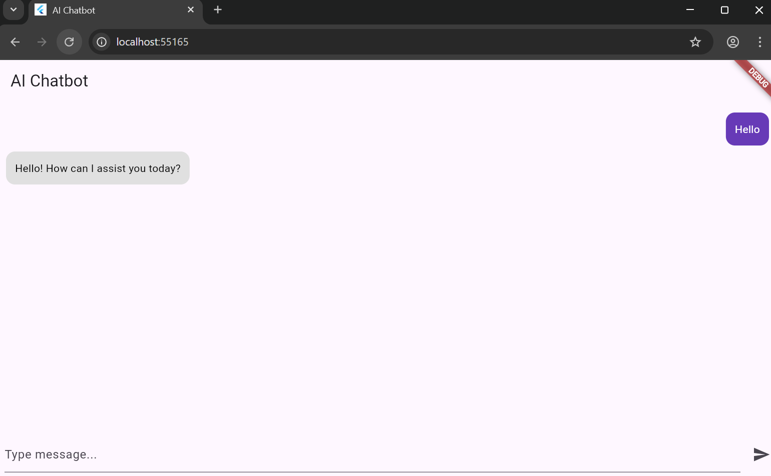
Login Functionality
Code:
import 'package:flutter/material.dart';
import 'package:http/http.dart' as http;
import 'dart:convert';
void main() {
runApp(const MyApp());
}
class MyApp extends StatelessWidget {
const MyApp({super.key});
@override
Widget build(BuildContext context) {
return MaterialApp(
debugShowCheckedModeBanner: false,
title: "AI Chatbot",
theme: ThemeData(
primarySwatch: Colors.deepPurple,
scaffoldBackgroundColor: Colors.grey[100],
),
home: const LoginPage(),
);
}
}
////////////////////////////////////////////////////
/// LOGIN PAGE
////////////////////////////////////////////////////
class LoginPage extends StatefulWidget {
const LoginPage({super.key});
@override
State<LoginPage> createState() => _LoginPageState();
}
class _LoginPageState extends State<LoginPage> {
final emailController = TextEditingController();
final passwordController = TextEditingController();
void login() {
String email = emailController.text;
String password = passwordController.text;
if (email == "admin@gmail.com" && password == "123456") {
Navigator.pushReplacement(
context,
MaterialPageRoute(builder: (context) => const ChatPage()),
);
} else {
ScaffoldMessenger.of(context).showSnackBar(
const SnackBar(content: Text("Invalid Login Credentials")),
);
}
}
@override
Widget build(BuildContext context) {
return Scaffold(
body: Container(
decoration: const BoxDecoration(
gradient: LinearGradient(
colors: [Colors.deepPurple, Colors.purpleAccent],
begin: Alignment.topCenter,
end: Alignment.bottomCenter,
),
),
child: Center(
child: Card(
elevation: 10,
margin: const EdgeInsets.all(20),
child: Padding(
padding: const EdgeInsets.all(25),
child: Column(
mainAxisSize: MainAxisSize.min,
children: [
const Icon(Icons.smart_toy,
size: 70, color: Colors.deepPurple),
const SizedBox(height: 10),
const Text(
"AI Chatbot Login",
style:
TextStyle(fontSize: 22, fontWeight: FontWeight.bold),
),
TextField(
controller: emailController,
decoration: const InputDecoration(labelText: "Email"),
),
TextField(
controller: passwordController,
obscureText: true,
decoration: const InputDecoration(labelText: "Password"),
),
const SizedBox(height: 20),
ElevatedButton(
onPressed: login,
child: const Text("Login"),
)
],
),
),
),
),
),
);
}
}
////////////////////////////////////////////////////
/// CHATBOT PAGE
////////////////////////////////////////////////////
class ChatPage extends StatefulWidget {
const ChatPage({super.key});
@override
State<ChatPage> createState() => _ChatPageState();
}
class _ChatPageState extends State<ChatPage> {
final TextEditingController controller = TextEditingController();
List<Map<String, String>> messages = [];
bool isLoading = false;
String apiKey =
"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";
Future<void> sendMessage() async {
if (controller.text.isEmpty) return;
String userMessage = controller.text;
setState(() {
messages.add({"role": "user", "content": userMessage});
isLoading = true;
});
controller.clear();
try {
final response = await http.post(
Uri.parse("https://openrouter.ai/api/v1/chat/completions"),
headers: {
"Authorization": "Bearer $apiKey",
"Content-Type": "application/json",
},
body: jsonEncode({
"model": "openai/gpt-3.5-turbo",
"messages": messages,
}),
);
if (response.statusCode == 200) {
final data = jsonDecode(response.body);
String reply = data["choices"][0]["message"]["content"];
setState(() {
messages.add({"role": "assistant", "content": reply});
isLoading = false;
});
} else {
setState(() {
messages.add({
"role": "assistant",
"content": "Error ${response.statusCode}"
});
isLoading = false;
});
}
} catch (e) {
setState(() {
messages.add({"role": "assistant", "content": "Error: $e"});
isLoading = false;
});
}
}
Widget buildMessage(Map<String, String> message) {
bool isUser = message["role"] == "user";
return Row(
mainAxisAlignment:
isUser ? MainAxisAlignment.end : MainAxisAlignment.start,
children: [
if (!isUser)
const CircleAvatar(
backgroundColor: Colors.deepPurple,
child: Icon(Icons.smart_toy, color: Colors.white),
),
Container(
margin: const EdgeInsets.all(8),
padding: const EdgeInsets.all(12),
constraints: const BoxConstraints(maxWidth: 250),
decoration: BoxDecoration(
color: isUser ? Colors.blue : Colors.white,
borderRadius: BorderRadius.circular(15),
),
child: Text(
message["content"] ?? "",
style: TextStyle(color: isUser ? Colors.white : Colors.black),
),
),
if (isUser)
const CircleAvatar(
backgroundColor: Colors.blue,
child: Icon(Icons.person, color: Colors.white),
),
],
);
}
void logout() {
Navigator.pushReplacement(
context,
MaterialPageRoute(builder: (context) => const LoginPage()),
);
}
@override
Widget build(BuildContext context) {
return Scaffold(
appBar: AppBar(
title: const Text("AI Chatbot"),
backgroundColor: Colors.deepPurple,
actions: [
const Padding(
padding: EdgeInsets.only(right: 10),
child: CircleAvatar(
backgroundColor: Colors.white,
child: Icon(Icons.person, color: Colors.deepPurple),
),
),
IconButton(
icon: const Icon(Icons.logout),
onPressed: logout,
),
],
),
body: Column(
children: [
Expanded(
child: ListView.builder(
padding: const EdgeInsets.all(10),
itemCount: messages.length,
itemBuilder: (context, index) {
return buildMessage(messages[index]);
},
),
),
if (isLoading) const CircularProgressIndicator(),
Row(
children: [
Expanded(
child: Padding(
padding: const EdgeInsets.all(8),
child: TextField(
controller: controller,
decoration: const InputDecoration(
hintText: "Type your message...",
border: OutlineInputBorder(),
),
),
),
),
IconButton(
icon: const Icon(Icons.send, color: Colors.deepPurple),
onPressed: sendMessage,
)
],
)
],
),
);
}
}

Result:
